**Web Technology for bioinformatics**

Name - Dharineesh K S Date - 5/10/2021

Regno - 123013012 Ex.no - 02

**Aim:**

To create a webpage using html, css, php and mysql.

**Task - 1:**

Write a PHP script to input the sequence and display the output.

**Algorithm:**

Step 1 : Write html script to input protein sequence and redirect to php script(html file).

Step 2 : Write php scripts to take input protein sequences by using the $_POST

method(php file).

Step 3 : Extract the one letter from sequence using substr function and iterate letter through

loops and calculates the properties of amino acids.

Step 4: print the result with properties.

**Program:**

**The code below is written in an html file:**

| **<!DOCTYPE html>**  **<!--**  **Author : Dharineesh K S**  **Regno : 123013012**  **-->**  **<head>**  **<title>ex2_task1_html</title>**  **<style>**  **body{**  **font-family: "Times New Roman";**  **}**  **</style>**  **</head>**  **<body>**  **<form method="POST" action="ex2_task1_php.php">**  **<table align="center">**  **<tr>**  **<td><textarea rows="20" cols="30" name="seq" placeholder="Enter protein sequence"></textarea></td>**  **</tr>**  **<tr><td colspan="2">**  **<pre> <input type="submit" value="calculate"> <input type="reset" value="clear"> </pre>**  **</td>**  **</tr>**  **</table>**  **</form>**  **</body>**  **</html>** |
| --- |

**Output of html script:**

Input sequence:

“VHLTAEEKAHVSGLWGKVNTEEVGGEALGRLLVVYPWTQRFFETFGDLSSANAIMNNPKVKAHGKKVLSSFSDGLKNLDNLKGTFAALSELHCDKLHVDPENFKLLGNVLVCVLAHHFGKEFTPQVQAAYQKIVAGVANALAHKYH”.

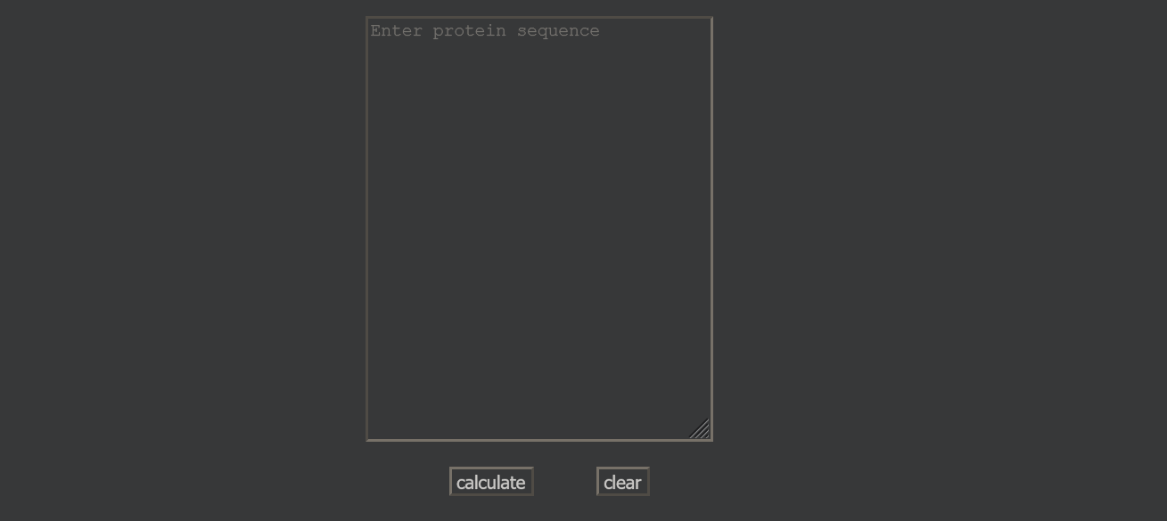

**The code below is written in a php file:**

| **<?php**  **/\***  **Author : Dharineesh K S**  **Regno : 123013012**  **\*/**  **echo "**  **<html>**  **<head>**  **<title>ex2_task1_php</title>**  **<style type=\"text/css\">**  **body {**  **font-family: \"Times New Roman\";**  **margin-top: 10%;**  **}**  **table {**  **width: 50%;**  **}**  **tr:nth-child(even) {**  **background-color: #f2f2f2 ;**  **}**  **</style>**  **</head> ";**  **echo"<body>";**  **$seq = $_POST["seq"];**  **$tiny = 0;**  **$small = 0;**  **$aliphatic = 0;**  **$aromatic = 0;**  **$nonpolar = 0;**  **$polar = 0;**  **$charged = 0;**  **$basic = 0;**  **$acidic = 0;**  **for($i=0;$i<strlen($seq);$i++)**  **{**  **$sub = substr($seq,$i,1);**  **#tiny**  **if ($sub == "A" || $sub == "C" || $sub == "G" || $sub == "S" || $sub == "T")**  **{**  **$tiny++;**  **}**  **#small**  **if ($sub == "A" || $sub == "C" || $sub == "D" || $sub == "G" || $sub == "N" || $sub == "P" || $sub == "S" || $sub == "T" || $sub == "V")**  **{**  **$small++;**  **}**  **#aliphatic**  **if ($sub == "A" || $sub == "I" || $sub == "L" || $sub == "V")**  **{**  **$aliphatic++;**  **}**  **#aromatic**  **if ($sub == "F" || $sub == "H" || $sub == "W" || $sub == "Y")**  **{**  **$aromatic++;**  **}**  **#nonpolar**  **if ($sub == "A" || $sub == "C" || $sub == "F" || $sub == "G" || $sub == "I" || $sub == "L" || $sub == "M" || $sub == "P" || $sub == "V" || $sub == "W" || $sub == "Y")**  **{**  **$nonpolar++;**  **}**  **#polar**  **if ($sub == "D" || $sub == "E" || $sub == "H" || $sub == "K" || $sub == "N" || $sub == "Q" || $sub == "R" || $sub == "S" || $sub == "T" || $sub == "Z")**  **{**  **$polar++;**  **}**  **#charged**  **if ($sub == "B" || $sub == "D" || $sub == "E" || $sub == "H" || $sub == "K" || $sub == "R" || $sub == "Z")**  **{**  **$charged++;**  **}**  **#basic**  **if ($sub == "H" || $sub == "K" || $sub == "R")**  **{**  **$basic++;**  **}**  **#acidic**  **if ($sub == "B" || $sub == "D" || $sub == "E" || $sub == "Z")**  **{**  **$acidic++;**  **}**  **}**  **echo"**  **<table align = center >**  **<tr><td>Tiny </td><td>(A+C+G+S+T) </td><td>".$tiny." </td></tr>**  **<tr><td>Small </td><td>(A+C+D+G+N+P+S+T+V) </td><td>".$small." </td></tr>**  **<tr><td>Aliphatic </td><td>(A+I+L+V) </td><td>".$aliphatic."</td></tr>**  **<tr><td>Aromatic </td><td>(F+H+W+Y) </td><td>".$aromatic." </td></tr>**  **<tr><td>Nonpolar </td><td>(A+C+F+G+I+L+M+P+V+W+Y) </td><td>".$nonpolar." </td></tr>**  **<tr><td>Polar </td><td>(D+E+H+K+N+Q+R+S+T+Z) </td><td>".$polar." </td></tr>**  **<tr><td>Charged </td><td>(B+D+E+H+K+R+Z) </td><td>".$charged." </td></tr>**  **<tr><td>Basic </td><td>(H+K+R) </td><td>".$basic." </td></tr>**  **<tr><td>Acidic </td><td>(B+D+E+Z) </td><td>".$acidic." </td></tr></table>";**  **echo"</body>";**  **echo"</html>";**  **?>** |
| --- |

**Output of php script:**

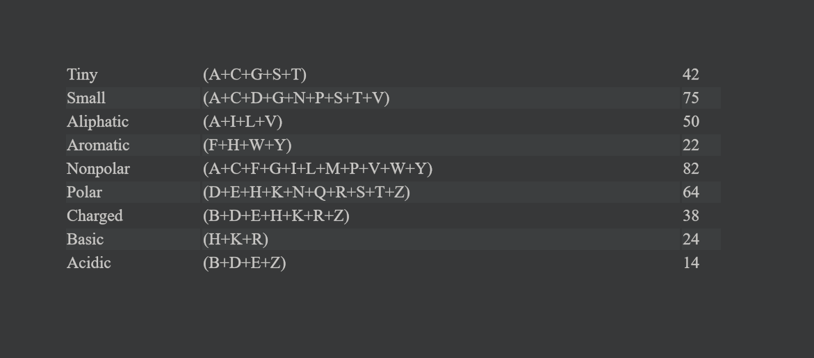

**Task 2 - A :**

Develop a Graphical user interface for Ligand Database using PHP and Mysql.

**Algorithm:**

Step 1: write a html code to get input molecular weight from the user.

Step 2: write a php script to create the user interface and search the

whole ligand database based on molecular weight.

Step 3: write a separate php script for the display image.

**Program:**

**The code below is written in an html file.**

| **<!DOCTYPE html>**  **<!--**  **Author : Dharineesh K S**  **Regno : 123013012**  **-->**  **<head>**  **<title>ex2_task2_A_html</title>**  **<style>**  **input[type=text] {**  **border: 1.5px solid;**  **}**  **input[type=submit] {**  **border: 3px solid;**  **padding-left: 5px;**  **padding-right: 25px;**  **padding-top: 3px;**  **padding-bottom: 3px;**  **}**  **table {**  **border: 2px solid;**  **padding: 10px;**  **}**  **body {**  **font-family: "Times New Roman";**  **}**  **</style>**  **</head>**  **<body>**  **<form method="POST" action="ex2_task2_php.php">**  **<table cellpadding = 10px align="center">**  **<tr>**  **<td></td>**  **<td align="center"><b>From</b></td>**  **<td align="center"><b>To</b></td>**  **</tr>**  **<tr>**  **<td><b>Molecular Weight</b></td>**  **<td><input type="text" name="from" placeholder="from"></td>**  **<td><input type="text" name="to" placeholder="to"></td>**  **</tr>**  **<tr>**  **<td></td>**  **<td colspan="2" align="center"><input type="submit" value="submit"></td>**  **</tr>**  **</table>**  **</form>**  **</body>**  **</html>** |
| --- |

**Output of html scrip:**

Input :

From : 115

To : 120



**The code below is written in a php file:**

| **<?php**  **/\***  **Author : Dharineesh K S**  **Regno : 123013012**  **\*/**  **echo "**  **<html>**  **<head>**  **<title>ex2_task2_A_php</title>**  **<style type=\"text/css\">**  **body {**  **font-family: \"Times New Roman\";**  **align-text : center;**  **}**  **table {**  **border-collapse : collapse**  **}**  **</style>**  **</head> ";**  **echo"<body>";**  **$con = mysqli_connect("localhost","root","") or die("Error in connection");**  **mysqli_select_db($con,"imp") or die("Database is not exists");**  **$from = $_POST["from"];**  **$to = $_POST["to"];**  **$sql = "select * from ligands where molecular_weight>=$from and molecular_weight<=$to";**  **$query = mysqli_query($con,$sql) or die("Error in sql query syntax");**  **echo "**  **<table align= 'center' border='2'>**  **<tr>**  **<th>Ligand_id </th>**  **<th>Pubchem_id </th>**  **<th>Ligand_name </th>**  **<th>Molecular weight </th>**  **<th>HBD </th>**  **<th>HBA </th>**  **<th>Rotatable bond </th>**  **<th>Structure </th>**  **</tr> ";**  **while($row = mysqli_fetch_array($query))**  **{**  **$id = $row['id'];**  **$pubchem_id = $row['pubchem_id'];**  **$name = $row['name'];**  **$molecular_weight = $row['molecular_weight'];**  **$Hbond_donor_count = $row['Hbond_donor_count'];**  **$Hbond_accep_count = $row['Hbond_accep_count'];**  **$rotatable_bond = $row['rotatable_bond'];**  **$str = $row['str'];**  **echo "**  **<tr>**  **<td>$id</td>**  **<td align=right>$pubchem_id</td>**  **<td align=right>$name</td>**  **<td align=right>$molecular_weight</td>**  **<td align=right>$Hbond_donor_count</td>**  **<td align=right>$Hbond_accep_count</td>**  **<td align=right>$rotatable_bond</td>**  **<td><img src=ex2_task2_structure.php?ids=$id width='200'height='200'></td>**  **</tr> ";**  **}**  **echo "</table>";**  **echo "<p align = center>HBD corresponds to Hydrogen Bond Donor Count and HBA corresponds to**  **Hydrogen Bond Acceptor Count.</p>";**  **mysqli_close($con);**  **echo"</body>";**  **echo"</html>";**  **?>** |
| --- |

**The code below is written in a php file:**

| **<?php**  **/\***  **Author : Dharineesh K S**  **Regno : 123013012**  **\*/**  **header("content-type:image/png");**  **$ligand_id = $_GET["ids"];**  **$con = mysqli_connect("localhost","root","") or die("Error in connection");**  **mysqli_select_db($con,"imp") or die("Database is not exists");**  **$sql = "select str from ligands where id='$ligand_id'";**  **$query = mysqli_query($con,$sql) or die("Error in sql query syntax");**  **$row = mysqli_fetch_array($query) or die("Error in mysql fetch syntax");**  **$struct = $row['str'];**  **echo "$struct";**  **mysqli_close($con);**  **?>** |
| --- |

**Output of php script:**

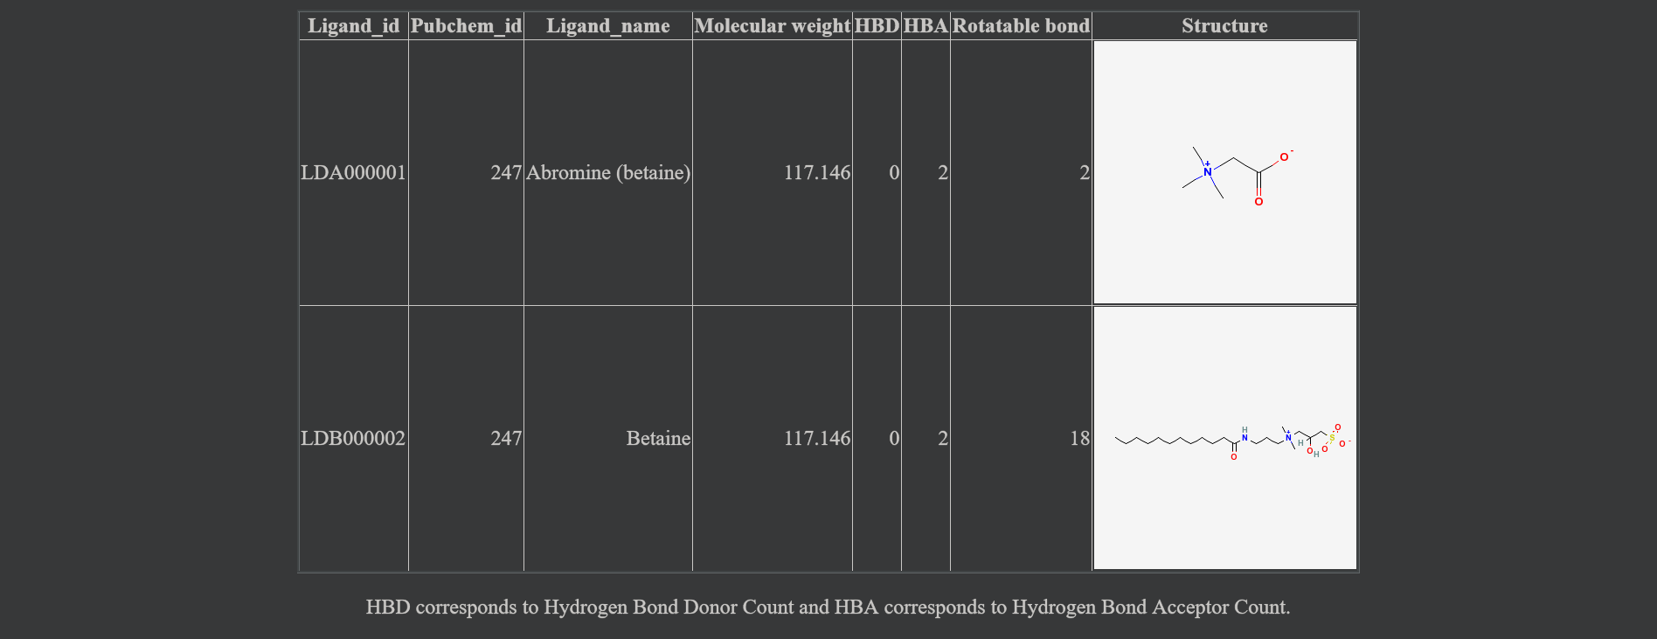

**Task 2 -B :**

Design a web page that contains alphabetical letters starting from A to Z.

Provide a hyperlink or internal references to each alphabetical letter which

redirects a PHP script that retrieves the ligand details staring with that

alphabetical letter.

**Algorithm:**

Step 1: write a html script to create hyperlinks for alphabets.

Step 2: write a php script to search the whole ligand database based on the first letter.

Step 3: print the output.

**Program:**

**The code below is written in an html file.**

| **<!DOCTYPE html>**  **<!--**  **Author : Dharineesh K S**  **Regno : 123013012**  **-->**  **<head>**  **<title>ex2_task2_B_alpha_hyperlinks_html</title>**  **<style>**  **table{**  **border: 1px solid;**  **}**  **body {**  **font-family: "Times New Roman";**  **}**  **table {**  **width: 50%;**  **}**  **tr:nth-child(even) {**  **background-color: #f2f2f2 ;**  **}**  **</style>**  **</head>**  **<body>**  **<p align = "center">Retrieves the ligand details starting with alphabetical letter</p>**  **<table align="center" cellpadding = 2px>**  **<tr>**  **<td align="center"><a href ="ex2_task2_alpha.php?var=A">A</a></td>**  **<td align="center"><a href ="ex2_task2_alpha.php?var=B">B</a></td>**  **<td align="center"><a href ="ex2_task2_alpha.php?var=C">C</a></td>**  **<td align="center"><a href ="ex2_task2_alpha.php?var=D">D</a></td>**  **<td align="center"><a href ="ex2_task2_alpha.php?var=E">E</a></td>**  **</tr>**  **<tr>**  **<td align="center"><a href ="ex2_task2_alpha.php?var=F">F</a></td>**  **<td align="center"><a href ="ex2_task2_alpha.php?var=G">G</a></td>**  **<td align="center"><a href ="ex2_task2_alpha.php?var=H">H</a></td>**  **<td align="center"><a href ="ex2_task2_alpha.php?var=I">I</a></td>**  **<td align="center"><a href ="ex2_task2_alpha.php?var=J">J</a></td>**  **</tr>**  **<tr>**  **<td align="center"><a href ="ex2_task2_alpha.php?var=K">K</a></td>**  **<td align="center"><a href ="ex2_task2_alpha.php?var=L">L</a></td>**  **<td align="center"><a href ="ex2_task2_alpha.php?var=M">M</a></td>**  **<td align="center"><a href ="ex2_task2_alpha.php?var=N">N</a></td>**  **<td align="center"><a href ="ex2_task2_alpha.php?var=O">O</a></td>**  **</tr>**  **<tr>**  **<td align="center"><a href ="ex2_task2_alpha.php?var=P">P</a></td>**  **<td align="center"><a href ="ex2_task2_alpha.php?var=Q">Q</a></td>**  **<td align="center"><a href ="ex2_task2_alpha.php?var=R">R</a></td>**  **<td align="center"><a href ="ex2_task2_alpha.php?var=S">S</a></td>**  **<td align="center"><a href ="ex2_task2_alpha.php?var=T">T</a></td>**  **</tr>**  **<tr>**  **<td align="center"><a href ="ex2_task2_alpha.php?var=U">U</a></td>**  **<td align="center"><a href ="ex2_task2_alpha.php?var=V">V</a></td>**  **<td align="center"><a href ="ex2_task2_alpha.php?var=W">W</a></td>**  **<td align="center"><a href ="ex2_task2_alpha.php?var=X">X</a></td>**  **<td align="center"><a href ="ex2_task2_alpha.php?var=Y">Y</a></td>**  **</tr>**  **<tr>**  **<td align="center"><a href ="ex2_task2_alpha.php?var=Z">Z</a></td>**  **</tr>**  **</table>**  **</body>**  **</html>** |
| --- |

**Output of html scrip:**



**The code below is written in a php file:**

| **<?php**  **/\***  **Author : Dharineesh K S**  **Regno : 123013012**  **\*/**  **echo "**  **<html>**  **<head>**  **<title>ex2_task2_B_alpha_hyperlinks_php</title>**  **<style type=\"text/css\">**  **body {**  **font-family: \"Times New Roman\";**    **}**  **table {**  **width: 50%;**  **}**  **tr:nth-child(even) {**  **background-color: #f2f2f2 ;**  **}**  **</style>**  **</head> ";**  **echo"<body>";**  **$con = mysqli_connect("localhost","root","") or die("Error in connection");**  **mysqli_select_db($con,"imp") or die("Database is not exists");**  **$alpha = $_GET["var"];**  **$arr = array("A" => "select * from ligands where name like 'A%'",**  **"S" => "select * from ligands where name like 'S%'",**  **"D" => "select * from ligands where name like 'D%'",**  **"F" => "select * from ligands where name like 'F%'",**  **"G" => "select * from ligands where name like 'G%'",**  **"H" => "select * from ligands where name like 'H%'",**  **"J" => "select * from ligands where name like 'J%'",**  **"K" => "select * from ligands where name like 'K%'",**  **"L" => "select * from ligands where name like 'L%'",**  **"Q" => "select * from ligands where name like 'Q%'",**  **"W" => "select * from ligands where name like 'W%'",**  **"E" => "select * from ligands where name like 'E%'",**  **"R" => "select * from ligands where name like 'R%'",**  **"T" => "select * from ligands where name like 'T%'",**  **"Y" => "select * from ligands where name like 'Y%'",**  **"U" => "select * from ligands where name like 'U%'",**  **"I" => "select * from ligands where name like 'I%'",**  **"O" => "select * from ligands where name like 'O%'",**  **"P" => "select * from ligands where name like 'P%'",**  **"Z" => "select * from ligands where name like 'Z%'",**  **"X" => "select * from ligands where name like 'X%'",**  **"C" => "select * from ligands where name like 'C%'",**  **"B" => "select * from ligands where name like 'B%'",**  **"N" => "select * from ligands where name like 'N%'",**  **"M" => "select * from ligands where name like 'M%'",**  **"V" => "select * from ligands where name like 'V%'",**  **);**  **$sql = $arr[$alpha];**  **$query = mysqli_query($con,$sql) or die("Error in sql query syntax");**  **echo " <table cellpadding = 5px align='center'>**  **<tr>**  **<th>Name</th>**  **<th>ID</th>**  **</tr> ";**  **while($row = mysqli_fetch_array($query))**  **{**  **$lidid = $row["id"];**  **$name = $row["name"];**  **echo "**  **<tr>**  **<td>$name</td>**  **<td>$lidid</td>**  **</tr>**  **";**  **}**  **echo "</table>";**  **mysqli_close($con);**  **echo"</body>";**  **echo"</html>";**  **?>** |
| --- |

**Output of php script:**

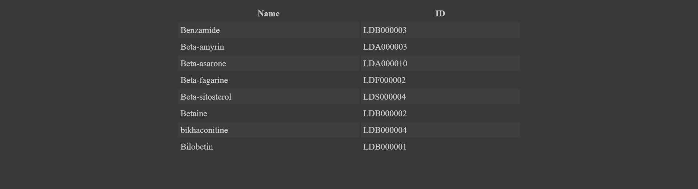

**Result:**

The given task is successfully executed.